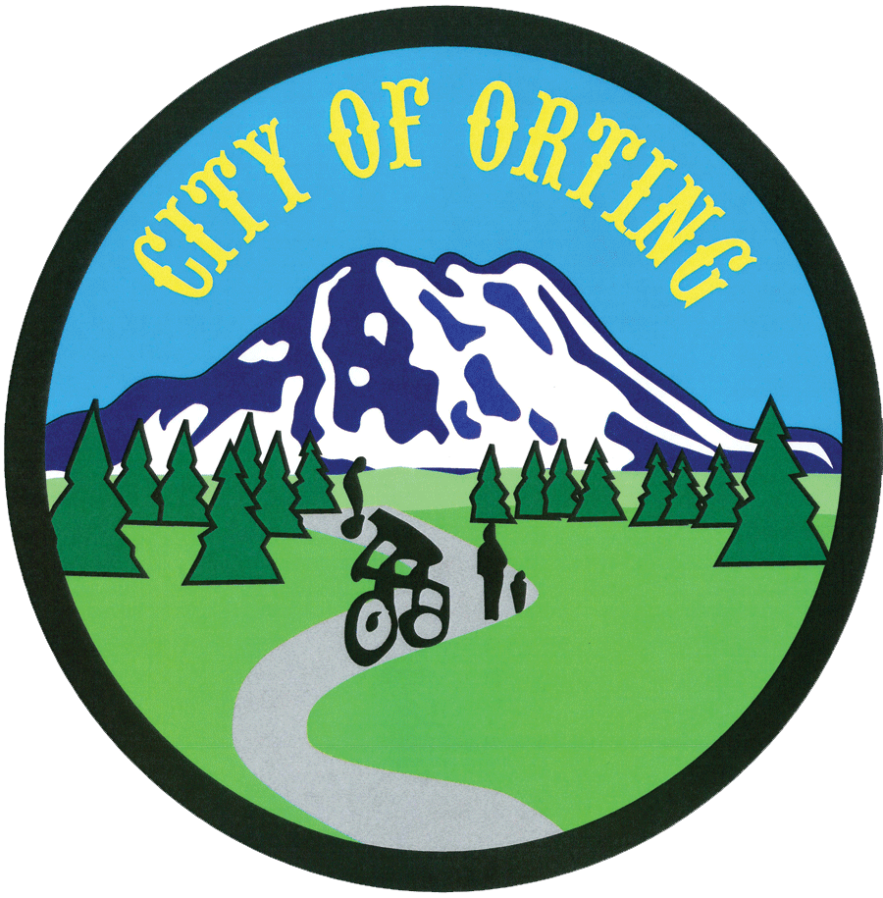
Commission/Board Application
City of Orting - Office of the City Clerk
PO Box 489-104 Bridge St. S., Orting, WA 98360
Phone: (360) 893-2219 - Fax: (360) 893-6809
www.cityoforting.org

FOR CITY CLERK USE ONLY:

Name: Date:

Mailing Address:

Phone: Alt. Phone:

Best time to contact you: Email Address:

How long at Residence:

Commission/Board desired: 1.)

2.)

Reason you are interested in serving:

Previous community activities:

Applicable education, occupational, and specialized experience:

Commissions/Boards make recommendations regarding monetary expenditures and/or benefits to certain areas of the Community.

- Can you foresee possible conflicts of interest with any of your current employment or civic positions:

- When making these recommendations do you feel you could be impartial and base your decision on the overall need and benefit of the Community:

Are there any days or evenings you are unavailable to meet? :

Signature of Applicant Date

