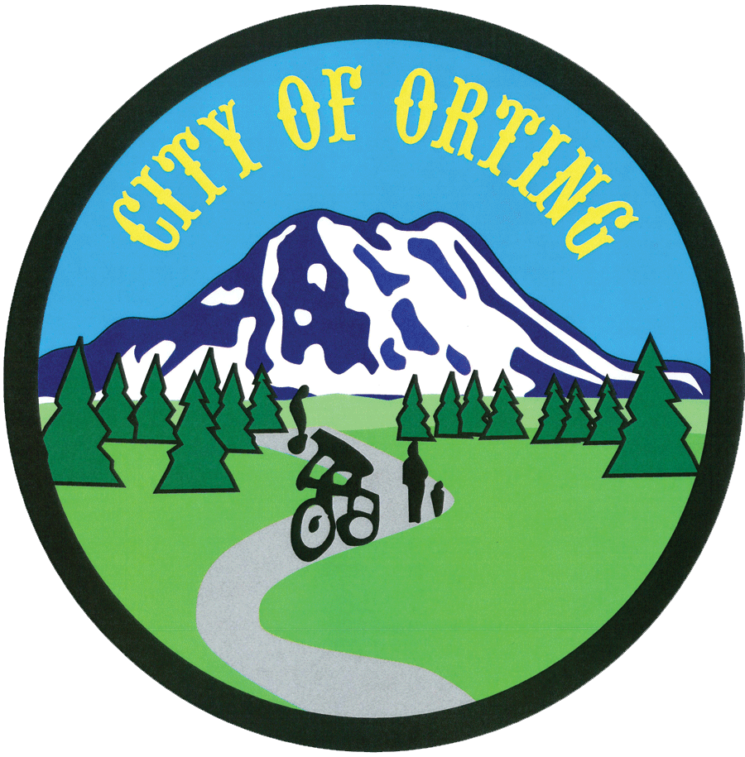
FOR CITY USE ONLY
Date Received:

Received By:

PDR Number:
Date Forwarded to Clerk:
Request for Public Records
RCW 42.56 and City of Orting Public Disclosure Policy
City of Orting - Office of the City Clerk
PO Box 489 – 104 Bridge St S., Orting, WA 98360
Phone: (360) 893-9008 - Fax: (360) 893-6809
www.cityoforting.org

PLEASE NOTE: This form, and all of the information contained therein, is a public record subject to disclosure when requested under the Public Records Act, Chapter 42.56 RCW.

Name: |  |  |  | Company/Organization:
Mailing Address:
Phone: |  |  |  | Email Address:
I prefer to be contacted by: |  | € Phone | € Email
I want: | € To review records in person (Clerk will contact you to schedule a time) |  |  | € Copies of Records, in the following format → |  | € Hard copy (charges will apply)  € Electronic (charges will apply)
Description of Records Requested:
Please be specific in describing the records being requested and any additional information that will help us locate them for you, such as senders/recipients, dates, subject matter. Additional information will assist us in locating the records as quickly as possible.

(Please continue on back or add additional sheets if necessary)
Within five business days of receipt of the request the City will respond by: (1) making the record available for inspection or copying; or, (2) acknowledging the receipt of request and providing a reasonable estimate of time the City requires to respond to the request; or; (3) denying the request. (RCW 42.56)
A copy of the City’s full Public Records Policy is available upon request.
--------------------------------------------------------------------------------------------------------------------------------------------
REQUESTOR SHALL READ AND ACKNOWLEDGE THE FOLLOWING STATEMENT
UPON SUBMITTING THIS REQUEST:
I understand that Public Records Act requests may not be used to promote the election of an official or promote or oppose a ballot proposition as prohibited by RCW 42.17A. I understand that if a list of individuals is provided to me by the City of Orting such list may not be used for commercial purposes as prohibited by RCW 42.56. If I or someone else uses these records for commercial purposes I may violate the rights of the individuals named and I may be liable for damages. “Commercial Purposes” means the person requesting the record intends the information will be used to communicate with the individuals named in the record for the purpose of facilitating profit-expecting activities. I certify the information obtained through this request for public records will not be used for commercial purposes, and acknowledge I have read the above statement.

Dated this __________ day of _______________________, 20_____.

__________________________________________ __________________
Signature of Requestor Date
#
Internal use only
Request Granted Request Denied - Reason:
Fees Collected: Hardcopy # of pages _____ x .15 = $________ Files e-mailed ____ x .05 / 4 files = $0.10 per GB to transmit
Completed Date Employee Signature

