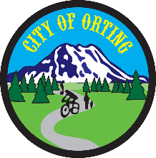

**Public Safety Committee Agenda**

**City Hall Council Chambers**

**104 Bridge Street South**

**July 9th, 2021, 8 AM**

Tony Blot, Co-Chair/Councilmember

Tony Belot, Co-Chair/Councilmember

Scott Larson, City Administrator

Chris Gard, Orting Police Chief

Kristin Swanson, Orting Police

**Call to Order**

**Approval of June, 2021 Minutes**

**Agenda**

* **Body Cameras**
* **4th of July**
* **Entry Level Police Interviews**

**Other**

**Action Items:**

Set Agenda for Next Meeting

Action Items to City Clerk for Study Session

**Adjournment**

**Next Meeting: *Friday, August 6th, 2021***