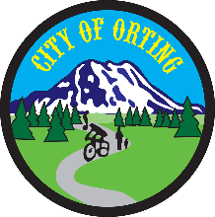

**Public Safety Committee Agenda  
Orting City Hall**

**104 Bridge St. S**

**April 2, 2021, 8 AM**

John Kelly, Co-Chair/Councilmember

Tony Belot, Co-Chair/Councilmember

Scott Larson, City Administrator

Chris Gard, Orting Police Chief

Kristin Swanson, Orting Police

**Call to Order**

**Approval of March, 2021 Minutes**

**Agenda**

* **SCORE ILA**
* **Vehicle Purchases**
* **Street Racing**
* **Committee Goals**

**Other**

**Action Items:**

Set Agenda for Next Meeting

Action Items to City Clerk for Study Session

**Adjournment**

**Next Meeting: *Friday, May 7th, 2021***