ORTING POLICE DEPARTMENT
WRITTEN STATEMENT FORM
104 Bridge Street South - Orting, WA - 98360 - (360) 893-3111

 |  |  | Incident Number
 |  |  | Date | Time  AM PM
Handwritten Statement Of: (LAST, FIRST MIDDLE) |  | Date of Birth (MM/DD/YYYY)
Home Address |  | City/State/Zip
Home Phone | Cell/Work Phone | E-mail Address
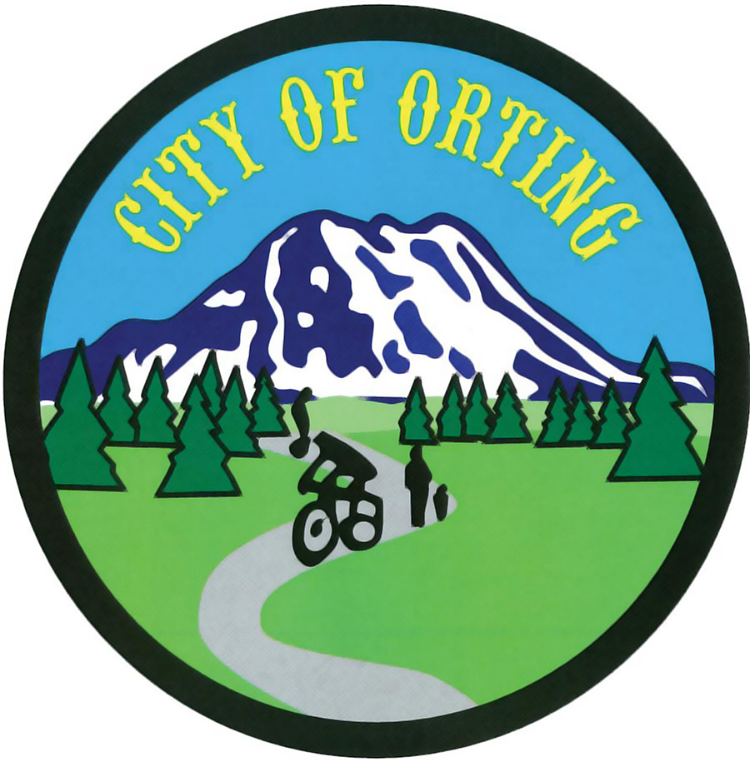

Narrative of Facts:

I certify under penalty of perjury under the laws of the state of Washington that the foregoing is true and correct to the best of my knowledge (RCW 9A.72.085). Furthermore, I agree to testify, in court, under oath, to the facts herein. I also understand that any false or misleading statements I make during the course of this investigation could result in criminal charges being filed against me.
Signature | Printed Name | Date (MM/DD/YYYY) | Time  AM PM
Please PRINT and SIGN form once complete. Return completed forms to business address above, or fax to: (360) 893-3129.

ORTING POLICE DEPARTMENT
WRITTEN STATEMENT FORM (Continued)
104 Bridge Street South - Orting, WA - 98360 - (360) 893-3111

Incident Number

Narrative of Facts (Continued):

I certify under penalty of perjury under the laws of the state of Washington that the foregoing is true and correct to the best of my knowledge (RCW 9A.72.085). Furthermore, I agree to testify, in court, under oath, to the facts herein. I also understand that any false or misleading statements I make during the course of this investigation could result in criminal charges being filed against me.
Signature | Printed Name | Date (MM/DD/YYYY) | Time  AM PM
Please PRINT and SIGN form once complete. Return completed forms to business address above, or fax to: (360) 893-3129.

