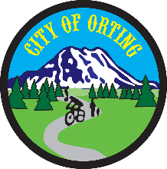

**Public Safety Committee Agenda  
Public Safety Building**

**401 Washington Ave SE, Orting WA**

**April 5, 2019 at 9:30 AM**

**John Kelly, Co-Chair/Councilmember**

**Joe Pestinger, Vice Chair/Councilmember**

**Mark Bethune, City Administrator**

**Kristin Swanson, Police Clerk**

**Call to Order**

(Please sign in)

**Approval of March 1, 2019 Minutes**

**Agenda Items**

* Transportation/162 Roundabout
* Fireworks

**Other**

Citizen Input

**Action Items:**

Set Agenda for Next Meeting.

Action Items: Inform City Clerk which items are moving to Study Session.

**Adjournment**

**Next Meeting: *Friday, May 3rd, 9:30 AM in the PSB***